Software Quality Assurance (SQA) is simply a way to assure quality in the software. It is the set of activities which ensure processes, procedures as well as standards are suitable for the project and implemented correctly.
Software Quality Assurance is a process which works parallel to development of software. It focuses on improving the process of development of software so that problems can be prevented before they become a major issue. Software Quality Assurance is a kind of Umbrella activity that is applied throughout the software process.
Generally the quality of the software is verified by the third party organization like international standard organizations.
Software Quality Assurance (SQA) encompasses
- SQA process
- specific quality assurance and quality control tasks (including technical reviews and a multitiered testing strategy)
- effective software engineering practice (methods and tools)
- control of all software work products and the changes made to them
- a procedure to ensure compliance with software development standards (when applicable)
- measurement and reporting mechanisms
Elements Of Software Quality Assurance:
- Standards: The IEEE, ISO, and other standards organizations have produced a broad array of software engineering standards and related documents. The job of SQA is to ensure that standards that have been adopted are followed an all work products conform to them.
- Reviews and audits: Technical reviews are a quality control activity performed by software engineers for software engineers. Their intent is to uncover errors. Audits are a type of review performed by SQA personnel(people employed in an organization) with the intent of ensuring that quality guidelines are being followed for software engineering work.
- Testing: Software testing is a quality control function that has one primary goal—to find errors. The job of SQA is to ensure that testing is properly planned and efficiently conducted for primary goal of software.
- Error/defect collection and analysis: SQA collects and analyzes error and defect data to better understand how errors are introduced and what software engineering activities are best suited to eliminating them.
- Change management: SQA ensures that adequate change management practices have been instituted.
- Education: Every software organization wants to improve its software engineering practices. A key contributor to improvement is education of software engineers, their managers, and other stakeholders. The SQA organization takes the lead in software process improvement which is key proponent and sponsor of educational programs.
- Security management: SQA ensures that appropriate process and technology are used to achieve software security.
- Safety: SQA may be responsible for assessing the impact of software failure and for initiating those steps required to reduce risk.
- Risk management: The SQA organization ensures that risk management activities are properly conducted and that risk-related contingency plans have been established.
Software quality assurance focuses on:
- software’s portability
- software’s usability
- software’s reusability
- software’s correctness
- software’s maintainability
- software’s error control
Software Quality Assurance has:
- A quality management approach
- Formal technical reviews
- Multi testing strategy
- Effective software engineering technology
- Measurement and reporting mechanism
Major Software Quality Assurance Activities:
- SQA Management Plan:
Make a plan for how you will carry out the SQA through out the project. Think about which set of software engineering activities are the best for project. check level of SQA team skills.
- Set The Check Points:
SQA team should set checkpoints. Evaluate the performance of the project on the basis of collected data on different check points.
- Multi testing Strategy:
Do not depend on a single testing approach. When you have a lot of testing approaches available use them.
- Measure Change Impact:
The changes for making the correction of an error sometimes re introduces more errors keep the measure of impact of change on project. Reset the new change to change check the compatibility of this fix with whole project.
- Manage Good Relations:
In the working environment managing good relations with other teams involved in the project development is mandatory. Bad relation of SQA team with programmers team will impact directly and badly on project. Don’t play politics.
Benefits of Software Quality Assurance (SQA):
- SQA produces high quality software.
- High quality application saves time and cost.
- SQA is beneficial for better reliability.
- SQA is beneficial in the condition of no maintenance for a long time.
- High quality commercial software increase market share of company.
- Improving the process of creating software.
- Improves the quality of the software.
- It cuts maintenance costs. Get the release right the first time, and your company can forget about it and move on to the next big thing. Release a product with chronic issues, and your business bogs down in a costly, time-consuming, never-ending cycle of repairs.
Disadvantage of SQA:
There are a number of disadvantages of quality assurance. Some of them include adding more resources, employing more workers to help maintain quality and so much more.

Software Review is systematic inspection of a software by one or more individuals who work together to find and resolve errors and defects in the software during the early stages of Software Development Life Cycle (SDLC). Software review is an essential part of Software Development Life Cycle (SDLC) that helps software engineers in validating the quality, functionality and other vital features and components of the software. It is a whole process that includes testing the software product and it makes sure that it meets the requirements stated by the client.
Usually performed manually, software review is used to verify various documents like requirements, system designs, codes, test plans and test cases.
Objectives of Software Review:
The objective of software review is:
- To improve the productivity of the development team.
- To make the testing process time and cost effective.
- To make the final software with fewer defects.
- To eliminate the inadequacies.
Process of Software Review:

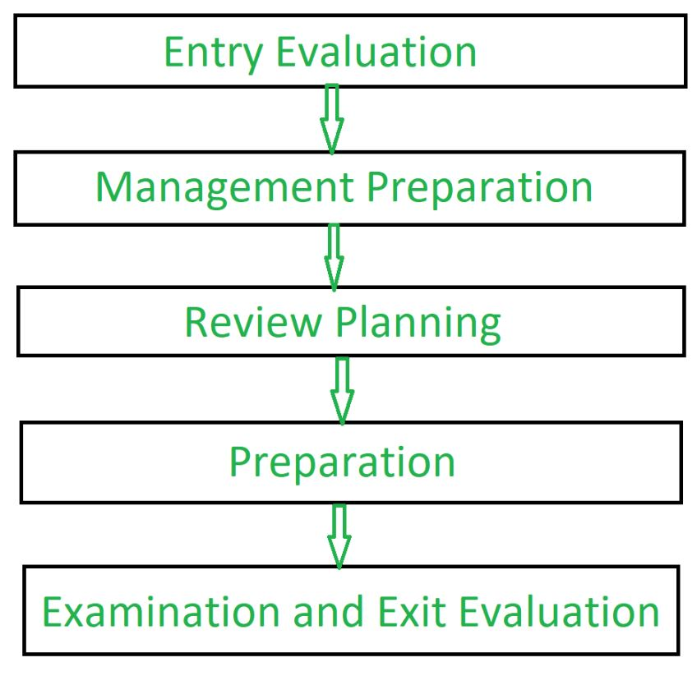
Types of Software Reviews:
There are mainly 3 types of software reviews:

- Software Peer Review:
Peer review is the process of assessing the technical content and quality of the product and it is usually conducted by the author of the work product along with some other developers.
Peer review is performed in order to examine or resolve the defects in the software, whose quality is also checked by other members of the team.
Peer Review has following types:
  - (i) Code Review:
Computer source code is examined in a systematic way.
  - (ii) Pair Programming:
It is a code review where two developers develop code together at the same platform.
  - (iii) Walkthrough:
Members of the development team is guided by author and other interested parties and the participants ask questions and make comments about defects.
  - (iv) Technical Review:
A team of highly qualified individuals examines the software product for its client’s use and identifies technical defects from specifications and standards.
  - (v) Inspection:
In inspection the reviewers follow a well-defined process to find defects.
- Software Management Review:
Software Management Review evaluates the work status. In this section decisions regarding downstream activities are taken.

- Software Audit Review:
Software Audit Review is a type of external review in which one or more critics, who are not a part of the development team, organize an independent inspection of the software product and its processes to assess their compliance with stated specifications and standards. This is done by managerial level people.
Advantages of Software Review:
- Defects can be identified earlier stage of development (especially in formal review).
- Earlier inspection also reduces the maintenance cost of software.
- It can be used to train technical authors.
- It can be used to remove process inadequacies that encourage defects.
Software Technical Review :
A software technical review is examined by a team of qualified software engineers for the suitability of the software product. This process can also be defined as a critical evaluation of an object in the software. Through the software technical review process, we can identify the errors or defects in the software product in the early phase itself.
Types of STRs :
The intent of this section is for the students to realize that the types of reviews that must be performed on a project are dependent upon the specific intermediate deliverables that are produced. Various application areas should also be described in the context of their review processes. The types of developmental modes are as follows:
- Development life cycle models –
a. Waterfall model
b. Rapid prototyping
c. Iterative enhancement
d. Maintenance activity modeling
- Current Standards –
a. Military standards
b. IEEE standards
c. NBS standards
Furthermore, the reviews are classified into two types: Formal and Informal reviews.
Informal reviews are meant to describe the type of review that typically occurs spontaneously among peers and in which the reviewers have any work and also not create a review report. Formal reviews are characterized by carefully planned meetings in which reviewers are held accountable for their participation in the review and in which a review report containing action items is generated and acted upon.
Informal reviews | Formal reviews
It is a type of review that typically occurs spontaneously among teams. | It is a type of review that is done by a team of software testers or the reviewer’s team.
It is generally done by Software developers or engineers. | It is done by the Reviewers and they are responsible for this review.
Here, no report is created as it is informal. | Here, a report is created as it is formal.
Importance of STRs :
Some of the reasons behind the importance of STRs are as follows:
- It also impacts employee morale. For some employees, such as maintenance personnel, the reviews may provide an opportunity to gain visibility of their work and, thus, will be viewed positively.
- It helps in software maintainability as it improves the developer’s general understanding of the whole system, which further facilitates error diagnosis during maintenance.
- It helps in the tracking of a project for both project management and customers. With this, we can track management, customers, and also developers’ projects.
- They provide feedback about the software and its development process. Examples of how review processes can impact the existing software development such as by identifying weaknesses in the software that will require additional validation effort in the future must also be provided.
Review Methodologies :
There are many variations to performing technical reviews. Most of these approaches involve a group meeting to assess a work product; however, variations of reviews exist that do not require a review group meeting. The three major approaches for performing the software technical review are given as follows:
- Walk-through –
Walk-throughs are a formal and very systematic type of verification method as compared to peer review. In a walkthrough, the author of the software document presents the document to other persons which can range from 2 to 7.
- Inspections –
Inspections are the most structured and formal type of verification method and are commonly known as inspections. It requires detailed preparation for the reviewing team members and it includes a very high systematic review of the software product.
- Audits –
It can also be described as an external type of review process as it serves to ensure that the software is correctly verified and working as per the requirement.
Formal Technical Review (FTR) is a software quality control activity performed by software engineers.

Objectives of formal technical review (FTR):
- Useful to uncover errors in logic, function, and implementation for any representation of the software.
- The purpose of FTR is to verify that the software meets specified requirements.
- To ensure that software is represented according to predefined standards.
- It helps to review the uniformity in software that is developed in a uniform manner.
- To make the project more manageable.
In addition, the purpose of FTR is to enable junior engineers to observe the analysis, design, coding, and testing approach more closely. FTR also works to promote backup and continuity to become familiar with parts of the software they might not have seen otherwise. Actually, FTR is a class of reviews that include walkthroughs, inspections, round-robin reviews, and other small-group technical assessments of software. Each FTR is conducted as a meeting and is considered successful only if it is properly planned, controlled, and attended.
Example:
suppose during the development of the software without FTR design cost 10 units, coding cost 15 units and testing cost 10 units then the total cost till now is 35 units without maintenance but there was a quality issue because of bad design so to fix it we have to re design the software and final cost will become 70 units. that is why FTR is so helpful while developing the software.

The review meeting:
Each review meeting should be held considering the following constraints- Involvement of people:
- Between 3, 4 and 5 people should be involve in the review.
- Advance preparation should occur, but it should be very short that is at the most 2 hours of work for every person.
- The short duration of the review meeting should be less than two hours. Gives these constraints, it should be clear that an FTR focuses on specific (and small) part of the overall software.
At the end of the review, all attendees of FTR must decide what to do.
- Accept the product without any modification.
- Reject the project due to serious error (Once corrected, another app needs to be reviewed), or
- Accept the product provisional (minor errors are encountered and should be corrected, but no additional review will be required).
The decision was made, with all FTR attendees completing a sign-of indicating their participation in the review and their agreement with the findings of the review team.

Review reporting and record keeping:
- During the FTR, the reviewer actively records all issues that have been raised.
- At the end of the meeting all these issues raised are consolidated and a review list is prepared.
- Finally, a formal technical review summary report is prepared.
A review summary report answers three questions:
- What was reviewed?
- Who reviewed it?
- What were the findings and conclusions?

Review guidelines:
Guidelines for the conducting of formal technical reviews should be established in advance. These guidelines must be distributed to all reviewers, agreed upon, and then followed. A review that is unregistered can often be worse than a review that does not minimum set of guidelines for FTR.
- Review the product, not the manufacturer (producer): FTR includes people and egos. while properly conducted FTR will give all participants a good feeling of accomplishment, and when conducted improperly, the FTR team will be pointed out clearly. the meeting tone will be only loose and constructive, the review team leader will ensure that the proper way of communication will be happening or not into the team or it will get out of control.
- Set an agenda and maintain it: one of the measure keys in the meeting is drift. FTR will always keep on track and schedule. the review leader is making and maintaining the meeting schedule and should not be afraid that many people drift sets in.
- Limit debate and rebuttal: whenever the issue is raised by the reviewer there will not be an impact on a universal agreement. rather than spending time with the questions, then issues will be further discussed off-line.
- Enunciate problem areas, but don’t attempt to solve every problem noted: A review is not a problem-solving session. The solution to a problem can often be accomplished for the producer alone or with the help of only one other individual. problem-solving should be postponed for a while until after the review meeting.
- Take written notes (record purpose): it is a good idea to take notes on the wallboard so that will be wording, and priorities can be assessed by other reviewers as information is recorded.
- Limit the number of participants and insist upon advance preparation: two heads are better than one, but 14 are not needed to be better than 4. We will keep the number of people involved to a minimum, all review team will must prepare in advance, and written comments will be requested by the review leader.
- Develop a checklist for each product that is likely to be reviewed: A checklist will help to structure of Review meeting and for the review leader and help to focus the reviewer on the important issues. checklist should be developed by the analysis, design, code, and even test documents.
- Allocate resources and time schedule for FTRs in order to maintain time schedule: it’s effective to review, they should be effective and it should be a task during the software engineering process. In addition, the time should be scheduled for modification that occurs as a result of an FTR.
- Conduct meaningful training for all reviewers in order to make reviews effective: To be effective for all the reviews at first some have received formal training. it will stress both process-related and the human psychological side of the reviews. for every person who are to participate in reviews which is a one-month learning curve of 20 peoples.
- Review earlier reviews that serve as the base for the current review being conducted: it can be beneficial in uncovering problems with the review process itself. the first product to be reviewed should be the guidelines themselves because many variables have a successful review, a software organization should experiment to find approaches that work best in a local context. porter and his colleagues provide excellent guidance for this type of experiment.

